Name: Mriganka Patra
Email: mriganka.patra@cognizant.com
Emp ID: 2415820

Day 18
Sprint 1 Submission

Objective: Implement the base CRM logic with record types, automation, visibility settings, and user management

Task 1.6: As a sales manager, I want to auto-create an opportunity when a new Account is added so that sales tracking begins immediately.

- Go to setup > Object Manager

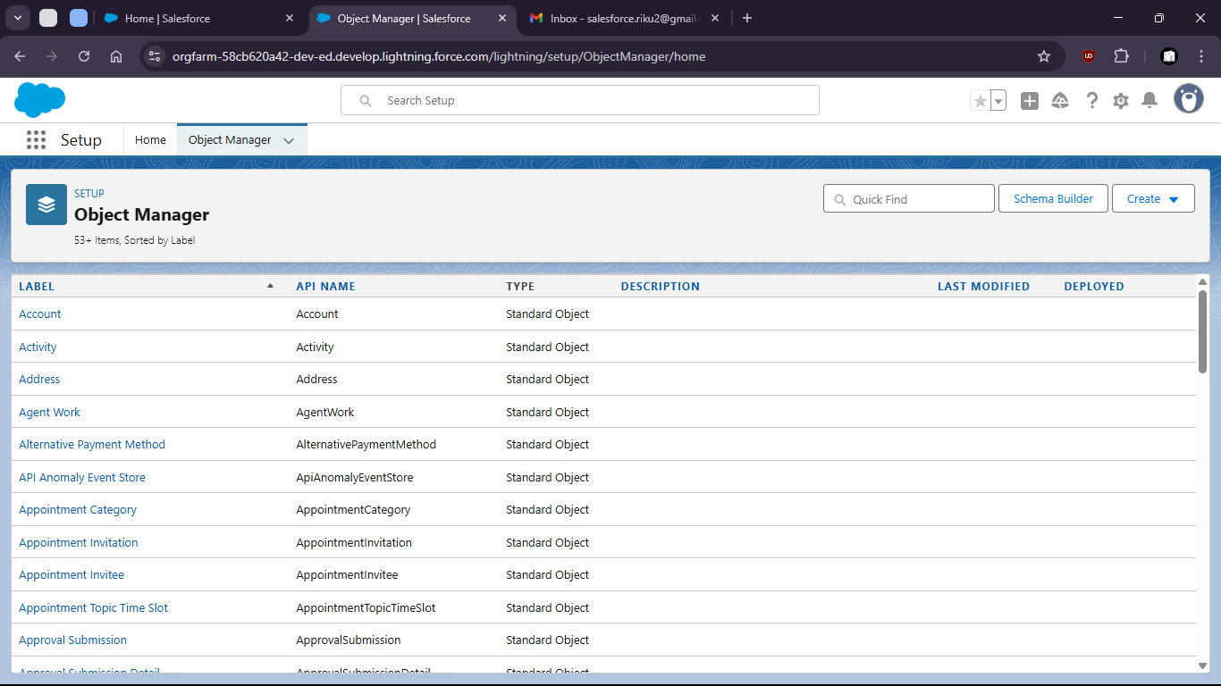

- select opportunity

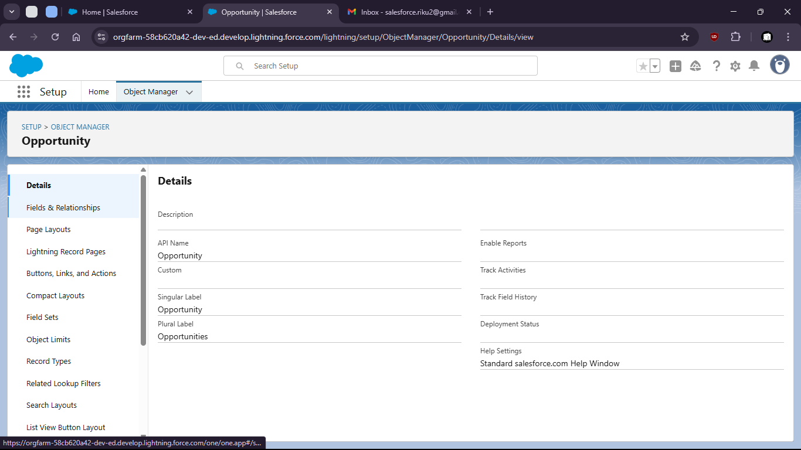

- Go to fields and relationships

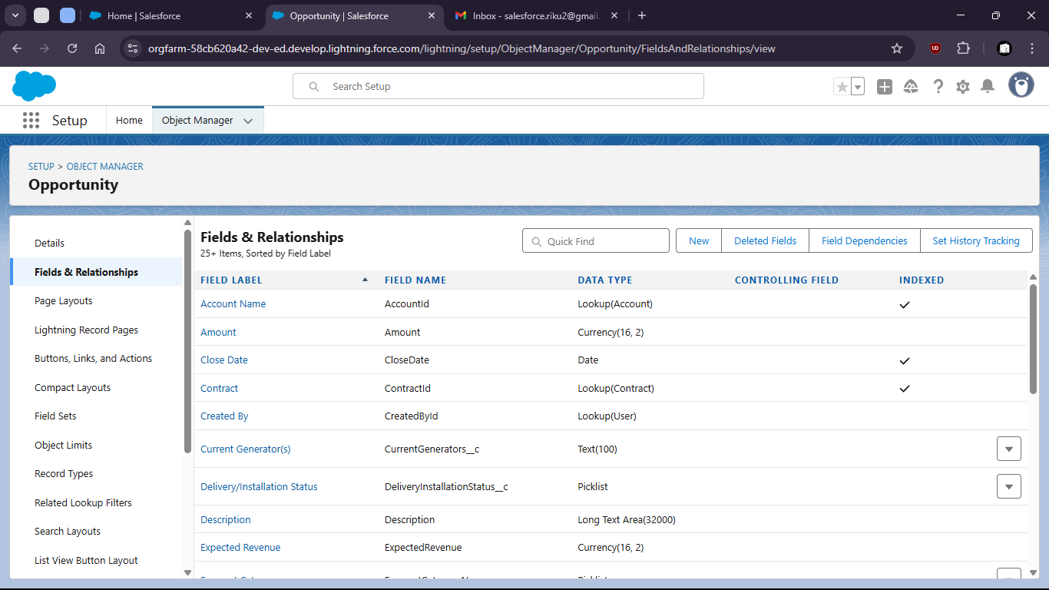

- Create new Field “Region”

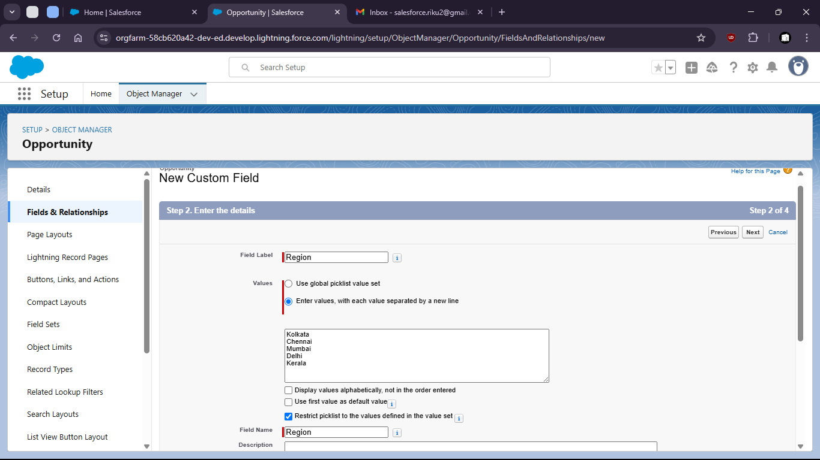

- Now search For Reports in App Launcher

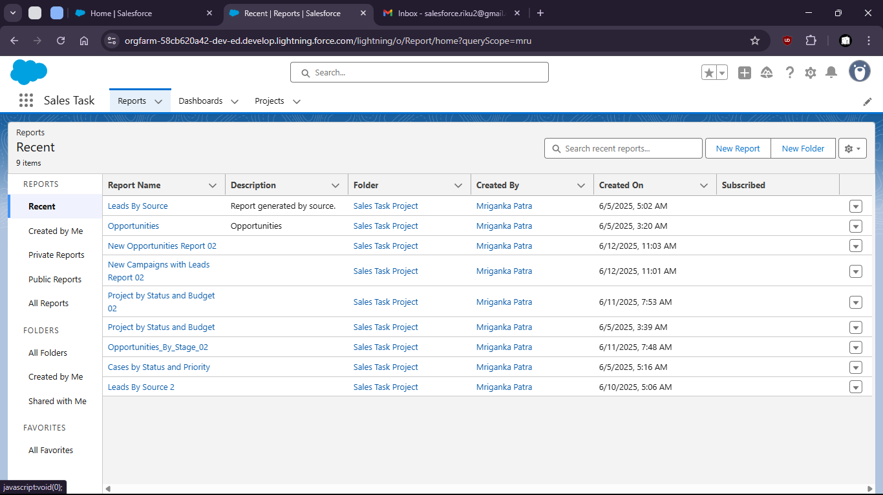

- Create new report on Opportunities

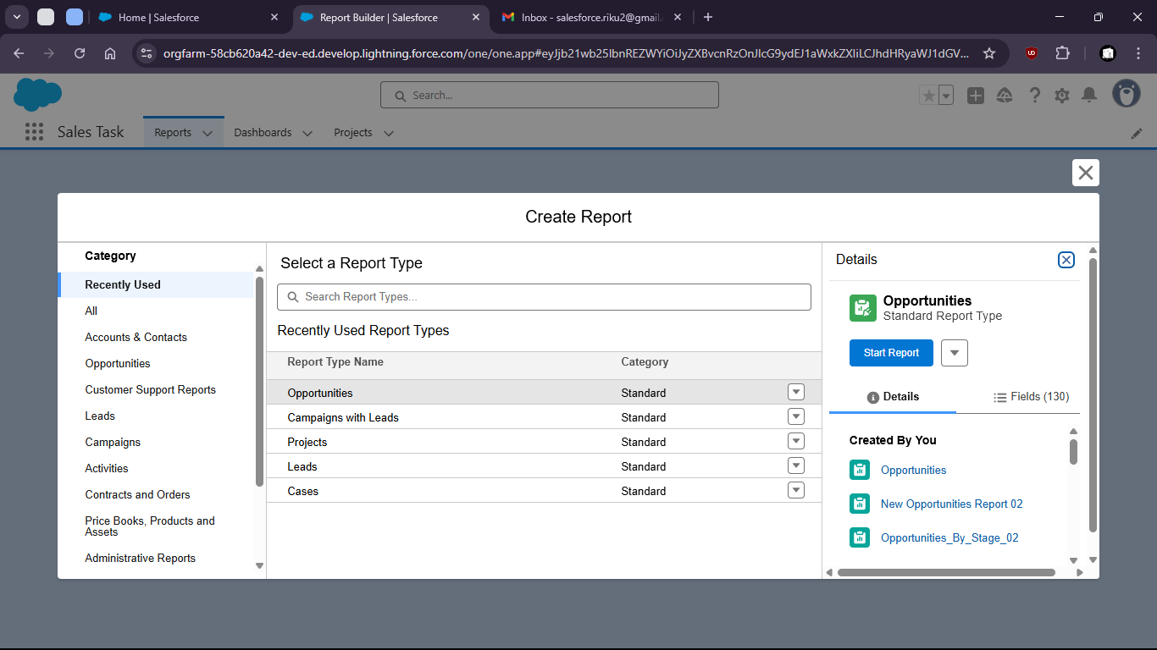

- Group by region

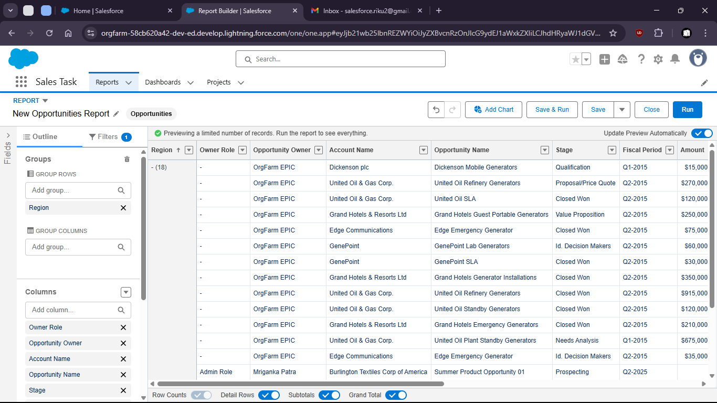

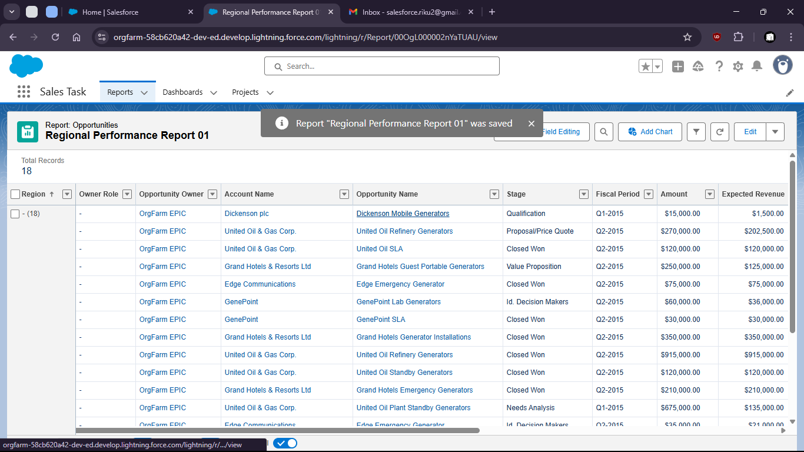

- Create new Dashboard on the Report

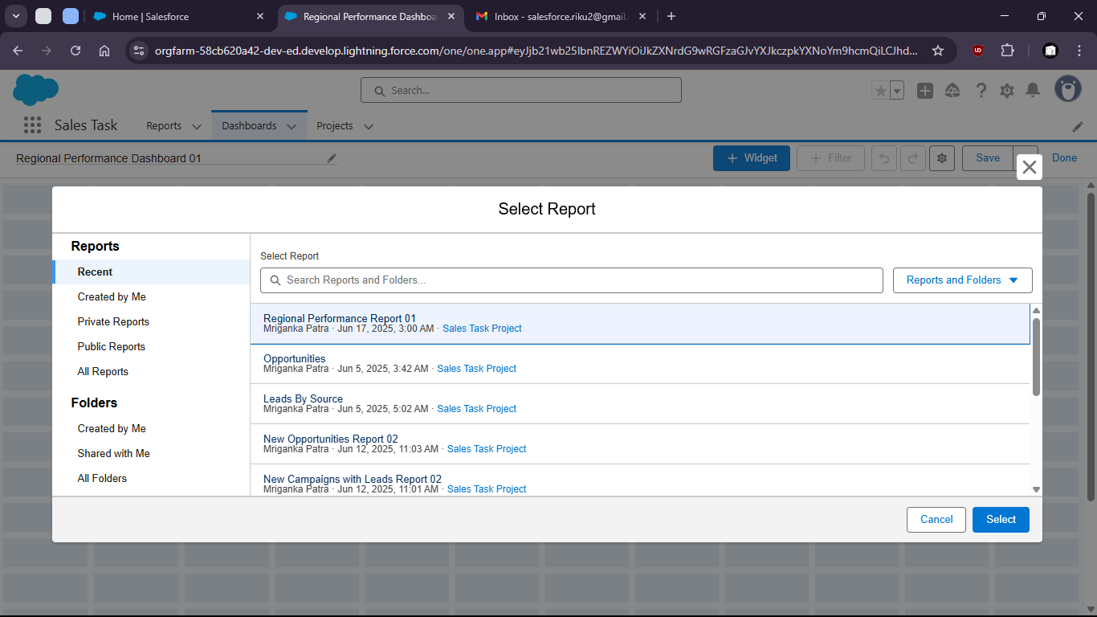

- Add widgets for better visualization

